Question no 1: What is word and find out the front view?

1. **MS WORD DEFINATION**

A **word** or phrase that has a specific or precise **meaning** within a given discipline or field and might have a different **meaning** in common usage: Set is a **term** of art used by mathematicians, and burden of proof is a **term** of art used by lawyers. Also called **word** of art.

* The Application and file name is WinWord
* The Extension of this is docx
* It’s default name of this software is document
* It is an utility software.

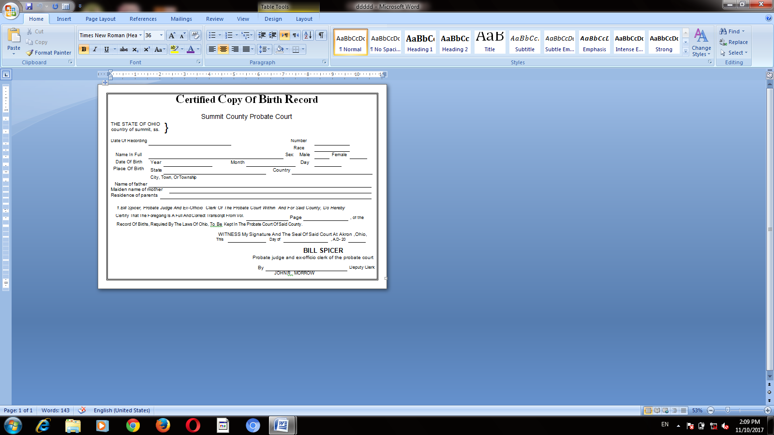

**Front view: General setting**

|  |
| --- |
| * Margin * Orientation * size |
|  |
|  |

* Title bar
* Action button
* Quick access tool bar
* Ruler
* Tab
* Ribbon
* Group button
* Vertical scroll bar
* Status bar

Question no 2: what are default tabs in home?

There are five types of default tab in home

* Clipboard
* Font
* Paragraph
* Styles
* Editing